Birstall Bowling Club Newsletter
Late September / October 2025

Club Competitions
Congratulations to the club competition winners and runners up this year. The results are below.

Ladies Competitions:
Championship: Jennie Golding, Runner Up: Jan Everitt
Handicap: Jennie Golding, Runner Up: Marlene Bartlett
2025 Three Wood: Jennie Golding, Runner Up: Marlene Bartlett
2024 Three Wood: Loraine Washington, Runner Up: Liz Marshall
Two Wood: Di Hurst, Runner Up: Marlene Bartlett
Pairs: Dawn Logan & Loraine Washington, Runners Up: Pat Davies & Cynthia Chapman

Men’s Competitions:
Championship: Andy Wye, Runner Up: Dave Burton
Handicap: Dean Grimbley, Runner Up: Bryan Allnutt
Maiden: TBC
Three Wood: John Hurst, Runner Up: Rick Everitt
Two Wood: John Hurst, Runner Up: Trevor Hanson
Pairs: TBC

Mixed Competitions:
Open: Jennie Golding, Runner Up: Dave Smith
2025 Adnett Pairs: Jan Everitt & Jim Marshall, Runners Up: Lesley Fowkes & John Corby
2024 Adnett Pairs: Dawn Logan & Stuart Washington, Runners Up: Loraine Washington & Eric Davies

County Competitions
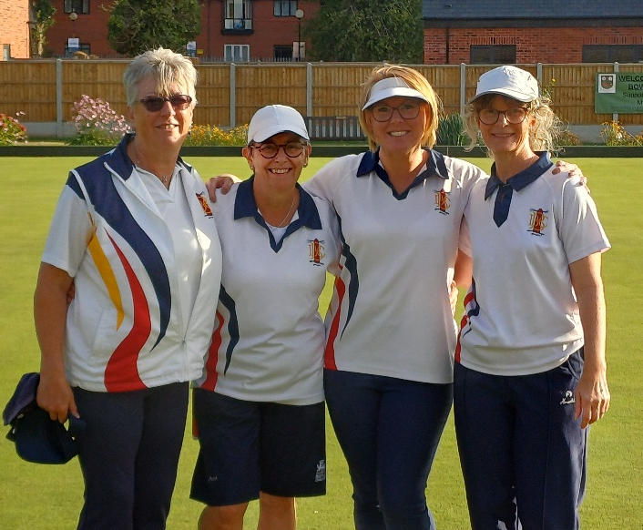
Our players were involved in six competitions at the county finals weekend.

Jennie Golding capped a great season by winning the Ladies Singles title for the fourth time, beating Kingscroft’s Sally-Ann Lewis-Wall in the final.

National quarter finalists Jan Everitt, Maria Brown, Di Hurst and Jennie won the Ladies Fours final, beating Viv Newman’s New Lount rink. Jan Di and Jennie were runners up in the Ladies Triples, losing to Katie Smith’s New Lount triple.

John Hurst and Roger Cooper won the Men’s Over 60s Pairs by beating Brush’s Rob Bunney and David Bettany. John and Andy Wye finished runners up in the Men’s Pairs, losing out to Holwell’s Chris Rodgers and Neil Hope.

Loraine Washington reached the semi-final of the Ladies Unbadged Singles before being beaten by Bagworth’s Emily Nicholls.

League News
The Men’s Loughborough Triples League has now been completed. Sands drew 4-4 at Brush in their last game to finish runners up in Division One, three points behind Shepshed. Lighthouse finished sixth in Division Two following an 8-0 win against St Margarets in their last game.

Our ladies were runners up in this year’s Monday Aussie Pairs League. We finished two points behind the winners East Leake.

Social News
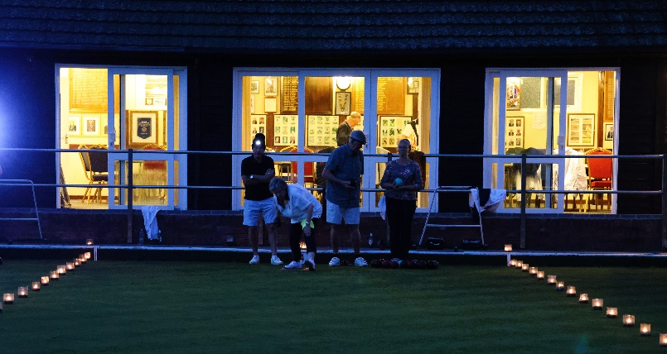
The quiz night and candlelit bowls were the latest hugely successful and enjoyable social nights. The next event is a Celebration Evening which is being held at the club on Saturday 4th October (7.00pm). The club has had a great season on and off the green and we are having a night to celebrate.

This is an informal evening with a faith supper. If you are attending, please put your name on the list on the Social Noticeboard, indicating whether you will be bringing sweet or savoury food.

CPR & Defibrillator Awareness Session
Hopefully all members are aware that we have a defibrillator on site at the club. This is situated outside the visitors changing room. The club will be hosting a CPR and Defibrillator Awareness Session on Saturday 18th October (10.00am – 12.00 noon). Organised by Pat Davies and St John Ambulance, this session will show you how to do CPR and use the defibrillator, should the need arise. If you would like to attend this free session, please add your name to the list on the mixed noticeboard, or speak to Pat.

AGM, Proposals and Officer Nominations
This year’s Annual General Meeting takes place at the club on Saturday 29th November (10.00am)

Any proposal you wish to put forward for the AGM must be with Honorary Secretary Di Hurst by Saturday 18th October. Information on how to do this is on noticeboards in both changing rooms.

There are still several vacancies for Management Committee and Non-Committee roles for next season. The list is displayed on the mixed noticeboard to add your name if you would like to take on a role and help the club to continue to be successful on and off the green. Please ensure that the person nominated for the role is happy to do it and you have a proposer and seconder.

Club Cleaning
Finally this month, many thanks to more than 30 members who have saved us around £2400 by cleaning the club during the season, with several doing the job more than once. We aim to repeat this again next season and urge more members to join the rota. If we get enough people, you will only have to do one session during the season and it doesn’t take long to do. If we went back to employing cleaners, subscriptions would have to rise by at least £25 to cover the cost.

