Birstall Bowling Club Newsletter
July 2025

County and National Competitions
Congratulations to Jan Everitt, Di Hurst and Jennie Golding who have qualified for Leamington by reaching the final of the ladies county triples competition. A comfortable quarter final win over Mary Groombridge’s Hinckley triple was followed by a narrow victory over Sue Aitken’s Little Bowden trio in the semi-final.

Maria Brown, Jan, Di and Jennie play Helen Lewis-Wall’s Kingscroft four in their rearranged ladies county fours semi-final at New Lount on Friday 4th July (6.00pm). Julie Beamish, Loraine Washington, Kathy Pateman and Pa Walker lost to Helen’s rink in the quarter finals.

The latter stages of the ladies county singles take place at Shepshed on Sunday 6th July starting at 10.00am. Jennie Golding has reached the quarter final and plays Knighton’s Alison Johnson. The semi-finals are played on the same day and both county finalists will qualify for Leamington.

In the men’s county triples, John Hurst, Roger Cooper and Shane Hayes were beaten at the quarter final stage by Jonathan Green’s Kingscroft triple.

Wins over holders Kingscroft and Hinckley have seen us reach the quarter final of the men’s county cup. We play Holwell on Friday 25th July (6.15pm) with two rinks home and two away.

Our ladies county unbadged team were beaten by Sileby in the first round.

Nationally, our ladies Top Club team play at Kingscroft on Saturday 5th July (6.00pm) in the Leicestershire area semi-final. Our men’s Top Club team lost to Holwell in their second game.

Jennie Golding and Shane Hayes have reached the Leicestershire area final of the National Mixed Pairs. They play Chris Rodgers and partner at home in a tie to be played by 17th July. .Julie Beamish and James Barrett (Hinckley) lost to Chris in the semi-final.

Jennie narrowly lost to Kat Bowman in the Leicestershire area final of the National Champion of Champions competition.

In the national mixed fours, Loraine and Stuart Washington (playing with Brush’s Mel and Pete Edge) were beaten by Carol Dixon’s New Lount four in the Leicestershire area semi-final.

Finally, our Two Fours team lost to Kingscroft in the Leicestershire semi-final.

We still have players involved in various national and county competitions. Home matches can be seen by looking in the diary near the bar. The latest results are on the websites www.bowlsengland.com and www.bowlsleicestershire-admin.com

Bramley Bowl
A win over Western Park has seen us reach the semi-final of the parks Bramley Bowl. We play Glenfield at home on Sunday 6th July (10.00am).

League News
In the Loughborough Triples League, Sands remain top of Division One and play at Belgrave on Monday 14th July (2.00pm) in their next game. Lighthouse are currently sixth in Division Two and play St Margarets away in their next match on Monday 21st July (also 2.00pm).

Six matches have been played in the Leicester League and we sit top of Division Two North. Our next match is away to St Margarets on Wednesday 9th July (6.15pm).

Our next match in the Ladies Aussie Pairs League is at Shepshed on Monday 14th July and our team in the Ladies Friday Triples League will be playing matches throughout July.

Social News
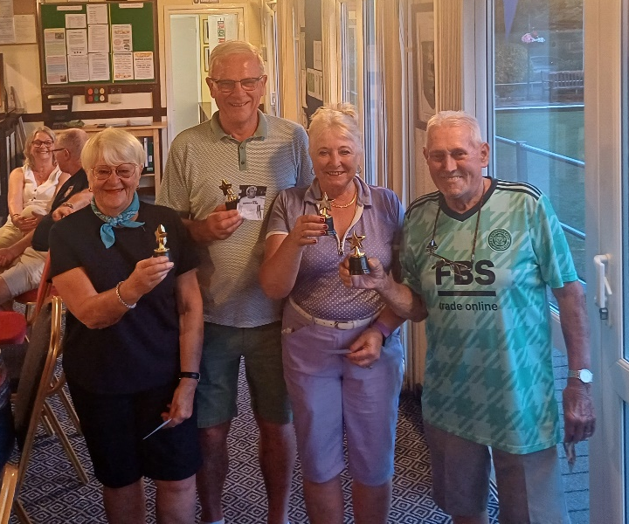
Well done to Chris and Barry Jarvis, Bill Jones and Loraine Washington who were the top team at our latest social event, Superstars, which involved teams playing six testing games. There were some superb prizes for the winners, including an almost genuine signed photo of Brian Jacks.

The next event takes place on Saturday 26th July (7.30pm). This is a Hawaiian themed Karaoke Singalong, with a special raffle and other fun activities, The cost is just £5.00 per person which includes raffle tickets and snacks. Please put your names on the list on the noticeboard near the bar by Saturday 19th July if you are attending. If you have any worthy raffle prizes (not the stuff in your garage!) please give them to a member of the social committee by Saturday 19th.

New Flooring
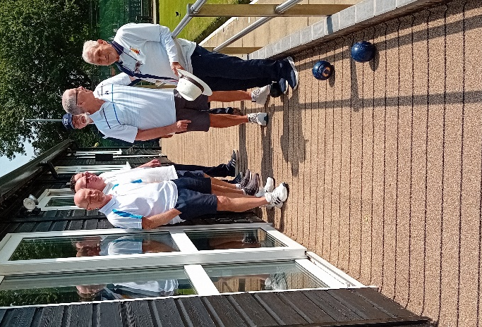
You will have noticed that we have had new flooring fitted on the veranda. This was installed recently by LazyLawn who specialise in supplying and fitting artificial surfaces throughout the country including from a branch in Oakham. This replaces the old tiles that were contracting and expanding depending on the weather. The new covering will make things safer for everyone and can be seen here along with some professional models who were hired at great expense.

