Birstall Bowling Club Newsletter
August 2025

Leamington 2025
Congratulations and good luck to our players who have qualified for Leamington this year.

Bowls England’s Competition Portal www.bowlsenglandcomps.com/season/6/2 has details of all the draws, and our players first games are below (details are correct at the time of writing but are subject to change due to players qualifying in multiple events, unforeseen circumstances etc).

Wednesday 20th August 12.45pm – Maria Brown, Jan Everitt, Di Hurst & Jennie Golding v Jenny Homer, Dawn Ford, Ruth Canham & Alison Noyes, Amesbury BC, Wiltshire (Women’s Fours)

Friday 22nd August 9.00am – Jan Everitt, Di Hurst & Jennie Golding v Lesley Whymark, Sue Alexander & Cheryl Salisbury, Littleport BC, Cambridgeshire (Women’s Triples)

Monday 25th August 9.00am – John Hurst & Andy Wye v Ashley Caress & Jordan Philpott, Royal Mail Cart BC, Lincolnshire (Men’s Pairs)

Tuesday 26th August 9.30am – Jennie Golding v Donna Brookes, Bletchley Town BC, Bucks (Women’s Singles)

Bowls England’s website www.bowlsengland.com/aviva-national-bowls-finals/ has all the information about Leamington with tickets available to be bought in advance from £5.50 per day for adults. Daily parking is available on Victoria Park for a mere £10.00 per day (or five days for £45.00) which is payable at the car park as you arrive. The entrance is off the roundabout under the railway bridge between Princes Drive (postcode CV31 3PH) and Park Drive.

Maria Brown, Jan Everitt, Di Hurst and Jennie Golding won their delayed county fours semi-final against Sally-Ann Lewis-Wall’s Kingscroft four to earn qualification.

Jennie Golding qualified for her third event with comfortable wins over Knighton’s Alison Johnson and New Lount’s Katie Smith in the county singles quarter and semi-finals respectively.

John Hurst and Andy Wye will play in the Men’s Pairs. Roger Cooper (subbing for John) and Andy beat New Lount’s Dave Simpson and John Arnett in the county semi final.

Roger Cooper was just one game away from qualifying in the Men’s Over 60’ Singles losing out to Lincolnshire’s Chris Hanslip in the last 32.

Jennie Golding and Shane Hayes reached the area final of the National Mixed Pairs before being beaten by Kat Bowman (New Lount) and Chris Rodgers (Holwell).

We were beaten by Kingscroft in the Leicestershire area semi-final of the ladies Top Club.

County Competitions
We have reached the semi-final of the men’s county cup where we play Shepshed on Friday 8th August (6.00pm) with two rinks at home and two away.

Jennie Golding got to the semi-final of the ladies county champion of champions competition, losing out to Kingscroft’s Sally-Ann Lewis-Wall.

Jan Everitt and Dave Smith lost out to Bagworth’s Michelle Wardle and Josh Brooks in the quarter final of the county mixed pairs.

Loraine Washington has reached the semi-final of the ladies county unbadged singles comp. She plays Bagworth’s Emily Nicholls on county finals weekend which is scheduled for Saturday 6th and Sunday 7th September. Full details of our players schedules will be confirmed shortly.

League News
There are still five matches to play for both of our teams in the Loughborough Triples League. The next matches are on Monday 11th August (2.00pm) with both teams at home. Sands (second in Division 1) play Soar Valley, and Lighthouse (sixth in Division 2) play Queens Park.

In the Leicester League, we finished top in Division Two North, losing just one game all season. As a result, we are promoted to Division One next season.

We play Little Bowden in the league cup semi-final at Blaby (neutral green) on Wednesday 6th August (6.00pm).

Bramley Bowl
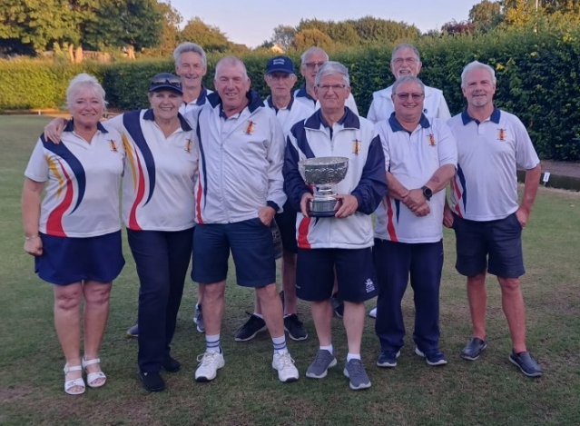
Well done to our team who won the Leicester City & District Parks Bramley Bowl competition.

Wins over Thurmaston, Western Park and Glenfield saw us reach the final where we beat Old Humberstone 3-1. Pictured are the winning team from the final. Captain Roger Bartlett thanked those who also played in the earlier rounds which helped us secure a place in the final.

Social Events
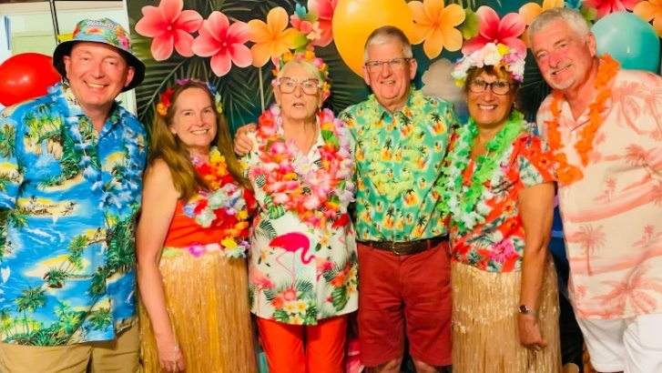
Our latest social event saw the club, and bar in particular, transformed as we held a Hawaiian themed party night with many members dressing up in colourful attire.

The next event is a quiz night which takes place on Friday 29th August (7.30pm). Full details are on the social noticeboard.

