Birstall Bowling Club Newsletter
September 2025

Leamington National Finals
Our players were involved in four events at the Bowls England National Finals this year.

Jan Everitt, Maria Brown, Di Hurst and Jennie Golding reached the quarter final of the Women’s Fours with wins against teams from Wiltshire, Durham and Worcestershire before being beaten by a four from Kings BC, Devon skipped by Harriet Stevens.

Jennie won her first game in the Women’s Singles against Buckinghamshire’s Donna Brooks but was then beaten by Warwickshire’s Emily Kernick who went on to reach the semi-final.

Jan, Di and Jennie lost out to Cheryl Salisbury’s triple from Littleport BC, Cambridgeshire in the first round of the Women’s Triples.

In the Men’s Pairs, John Hurst and Andy Wye were agonisingly beaten by just one shot in the first round by Ashley Caress and Jordan Philpott from Royal Mail Cart BC, Lincolnshire.

The players involved would like to thank everyone who sent messages, and particularly to those who went to Leamington to support, it was much appreciated.

County Competitions
This year, the county finals for both men and ladies are being held over one weekend with all games being played at Blaby. Our players are involved in six events and details are below.

Saturday 6th September
12.30pm: Ladies Unbadged Singles Semi Final – Loraine Washington v Emily Nicholls (Bagworth)
(The final of this competition will be played at 3.00pm on the same day with the winner of the above playing either Glenfield’s Jaswinder Gajebasia or Hinckley’s Jodi Faulkner).
12.30pm: Men’s Over 60s Pairs Final – John Hurst & Roger Cooper v Rob Bunney & David Bettany (Loughborough Brush)
3.00pm: Ladies Fours Final – Jan Everitt, Maria Brown, Di Hurst & Jennie Golding v Jan Elliott, Marthie du Preez, Sharon Cobb & Viv Newman (New Lount)

Sunday 7th September
9.30am: Ladies Triples Final – Jan Everitt, Di Hurst & Jennie Golding v Kat Bowman, Carol Dixon & Katie Smith (New Lount)
1.30pm: Men’s Pairs Final – John Hurst & Andy Wye v Chris Rodgers & Neil Hope (Holwell)
1.30pm: Ladies Singles Final – Jennie Golding v Sally-Ann Lewis-Wall (Kingscroft)

Support for our players over the weekend would be most welcome.

The County Presentation Lunch takes place on Sunday 19th October (12.00 noon) at Devonshire Place in Leicester. Information is in both changing rooms along with sheets for you to add your names and menu choices. Choices and payment should be made by Sunday 21st September.

Club Competitions
Most of the club finalists have been confirmed ahead of finals day on Sunday 14th September. The schedule of matches will be released shortly.

League News
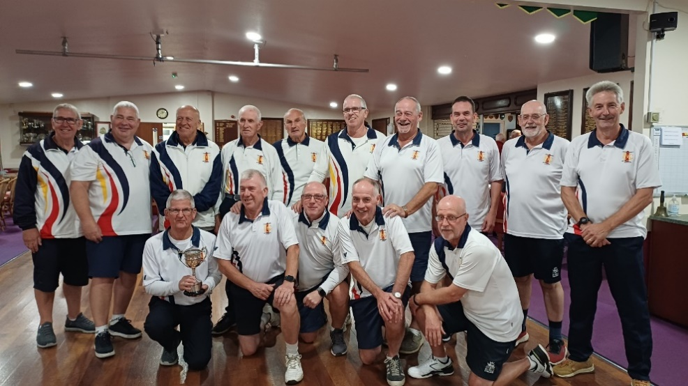
Congratulations to our men’s team who won the Leicester League Cup with a 72-57 win over Little Bowden in the final, which was played at Goodwood last month.

In the Loughborough Triples League, there are still two rounds of matches left to play. On Monday 8th September, Sands (second in Division One) play Belgrave at home and Lighthouse (sixth in Division Two) are away at Rothley. The following week, Sands are away to Brush and Lighthouse host St Margarets. All matches start at 2.00pm.

Social News
We have three Social Events taking place at the club in the next few weeks.

The “oh so easy” Quiz Night on Friday 5th September (7.30pm) is sold out. The cost is £4.00 per person which includes supper, and money can be paid to any management committee member. If you haven’t paid yet, please do so before the date if possible as this helps with the catering arrangements (you can pay on the night if you are unable to do so before). Complaints about the difficulty of the questions in the “oh so easy” quiz should be directed to a member of the Social Committee after the event!

On Friday 19th September (7.00pm for 7.30pm) we will be causing havoc on the green again by attempting to play Candlelit Bowls. This will be followed by a fish and chip supper. The cost is £10.00 per person and payment can be made on the night. A list is on the social noticeboard for you to add your names if you are attending, and there is a prize for the winning rink.

There will be an End of Season Celebration Evening on Saturday 4th October. Details relating to this will be displayed on the social noticeboard shortly.

Indoor Matches
As the outdoor season finishes at the end of this month, members will soon be concentrating on the indoor version of the sport.

Roger Bartlett has arranged seven matches throughout the indoor season, including a new fixture against Wellingborough. Sheets are in both changing rooms to indicate your availability. All matches are mixed and three of the seven matches will be followed by a meal.

