Birstall Bowling Club Newsletter
June 2025

Bowls England Bowls’ Big Weekend
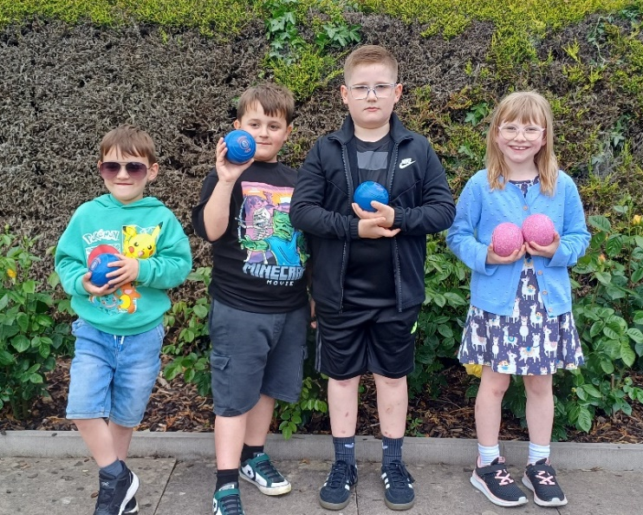
We had several visitors to the club for our session as part of Bowls England’s Bowls’ Big Weekend last month. These included the families of current members, with a number of youngsters keen to try out the sport.

Thanks to everyone who helped during the morning by welcoming visitors and offering advice and assistance to potential new members.

Club Competitions
Congratulations to Jan Everitt and Jim Marshall who won the Adnett Mixed Pairs. Runners Up were Lesley Fowkes and John Corby. Also well done to Loraine Washington who won last season’s delayed ladies Three Wood Singles competition. Runner up was Liz Marshall.

County Competitions
We have two teams through to the quarter finals of the ladies county fours competition. These are scheduled to take place at New Lount on Sunday 15th June at 10.00am with the semi finals to follow later the same day. Maria Brown, Jan Everitt, Di Hurst and Jennie Golding play Tricia Tams’ Kingscroft rink. Julie Beamish, Loraine Washington, Kathy Pateman and Pa Walker play Sally-Ann Lewis-Wall’s Kingscroft four, however this game may be played before the date due to Kingscroft’s Disability Bowls England commitments. Further information will be released in due course. Good luck to both our teams and any support on the day would be appreciated.

Maria Brown, Liz Marshall, Kathy Pateman and Loraine Washington reached the quarter final of the ladies senior fours before being beaten by Kath Rothera’s Wymeswold four.

Our ladies unbadged team start the defence of their title with a trip to Sileby on Wednesday 11th June (2.00pm).

Our men’s unbadged team were beaten at Wycliffe in the first round. We play Kingscroft in the first round of the men’s county cup on Friday 13th June (two rinks at home and two away).

Bowls Leicestershire’s competition website www.bowlsleicestershire-admin.com has all the details of our members progress in the various county competitions.

National Competitions
Our women’s Top Club team play Fosseway at home on Thursday 5th June (6.00pm).

Having beaten Sileby in the first round of the men’s Top Club our next game is away to Holwell on Friday 6th June (6.00pm). The Two Fours team beat Kingscroft in the first round and play Shepshed away in the next round (to be played by Sunday 15th June).

In the Tony Allcock Over 60s Mixed Two Fours competition, we were beaten by Hinckley in the first round by two shots.

Members are also involved in individual competitions and you can keep up to date with their progress by visiting the Competitions Portal section at www.bowlsengland.com

League News
Both of our teams won their latest games in the men’s Loughborough Triples League. The next fixtures on Monday 23rd June see Sands (currently top of Division One) at home to Thringstone, and Lighthouse (fourth in Division Two) away to Fosseway. Both matches start at 2.00pm.

We have played three games in the men’s Leicester League Division Two North and are in second place, one point behind Belgrave who we play at home in our next game on Wednesday 4th June (6.15pm).

The first match in the ladies Aussie Pairs competition takes place at home against Shepshed on Friday 6th June starting at 6.00pm. The format for this competition is three pairs with two points for each winning pair and two points for the aggregate score.

The first round of matches in the Ladies Friday Triples League take place on Friday 21st June.

Bramley Bowl
A win over Thurmaston means we have reached the quarter final of the Bramley Bowl. We play Western Park at home on Monday 9th June (6.00pm).

Social Events

Thanks to everyone who attended the sold out poptastic Popmaster Quiz at the end of last month. A great evening included some testing questions, particularly the later rounds as they went from the 60s to the 00s. Thanks also to those who organised and ran the night. We even had our own Ken Bruce helping to serve behind the bar.

Our next event is a “Superstars and Dining Night” on Friday 20th June. Thankfully this doesn’t involve cycling round the green or squat thrusts!! Further details will be on the noticeboard next to the bar shortly.

