Birstall Bowling Club Newsletter
December 2024

Potters Trip
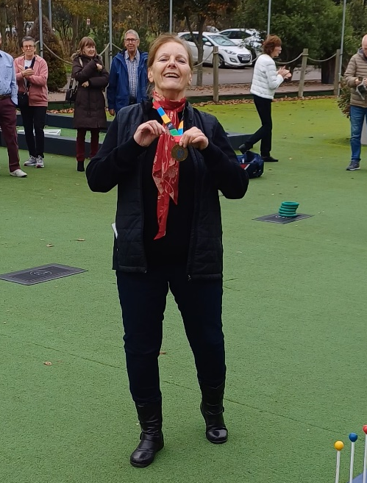
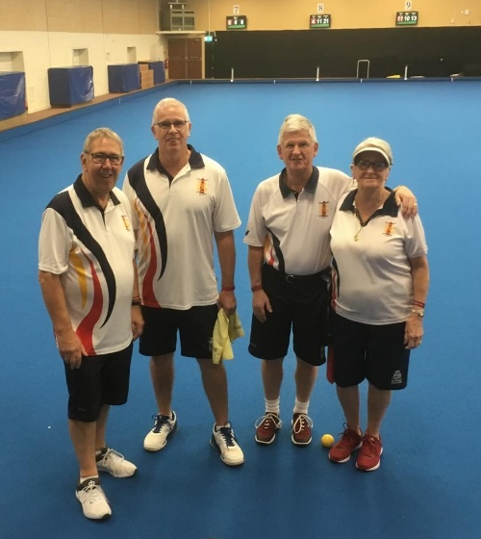
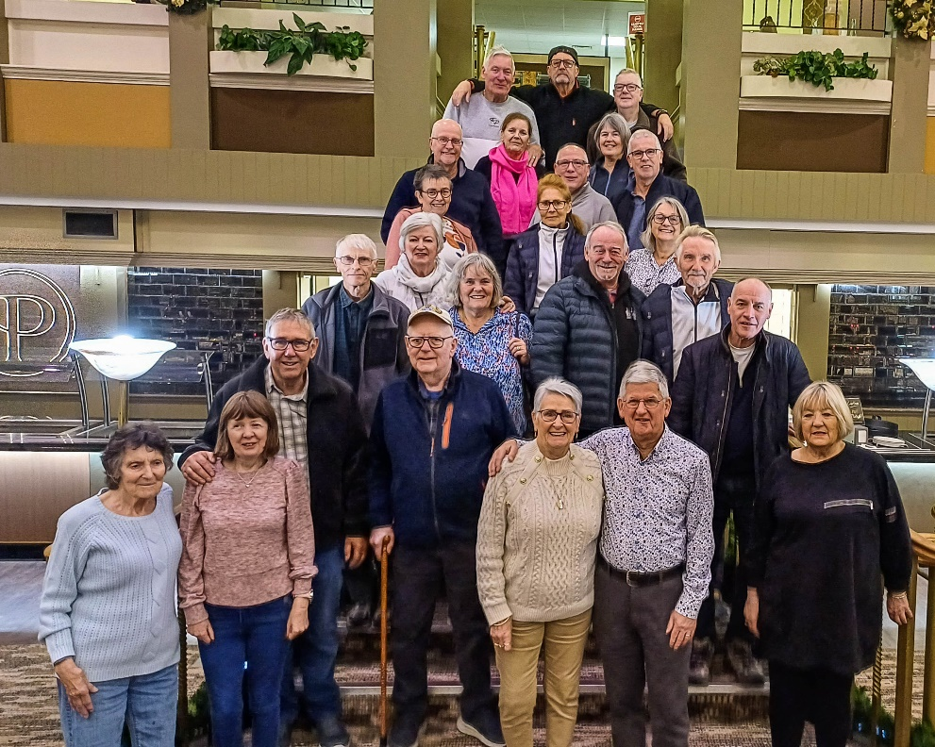
Last month, members travelled to Potters Resort for a five-day all-inclusive bowls break. There were 52 teams taking part in the bowls tournament. Well done to Marlene and Roger Bartlett, John Corby and Richard Smith whose rink reached the quarter finals, while Kathy Pateman, Di and John Hurst and a pool player reached the last 16. There are many activities to do during the break as well as the bowls, Kathy won a medal in the Chukka Hoop and Barbara Mullins won one for bowls on a snooker table. Thanks to Marlene for the information and photos.

Other News
AGM: The Annual General Meeting takes place on Saturday 7th December at the clubhouse starting at 10.00am. The Agenda, Officer’s Reports and Receipts and Payments summary were sent out last month. If you cannot attend, please let Honorary Secretary Di Hurst know so that she can add you to the list of apologies.

Christmas Party: This is being held at the club on Saturday 14th December with a revised start time of 6.30pm. If you are attending, please bring a pen with you as it will be needed for the games, and feel free to wear something black, white, gold or silver.

