Birstall Bowling Club Newsletter
October 2024

Club Competitions
Congratulations to the club competition winners and runners up this year. The results are below.

Ladies Competitions:
Championship: Jennie Golding, Runner Up: Jan Everitt
Two Wood: Di Hurst, Runner Up: Jan Everitt
Pairs: Kathy Pateman & Pa Walker, Runners Up: Janet Wildbore & Cynthia Chapman

Men’s Competitions:
Championship: Shane Hayes, Runner Up: Andy Wye
Handicap: Shane Hayes, Runner Up: Richard Smith
Maiden: Alan Hastings, Runner Up: Dermot Healy
Three Wood: Bob Cooper, Runner Up: Ian Lockington
Two Wood: Andy Wye, Runner Up: Ian Lockington
Pairs: Ian Lockington & Richard Smith, Runners Up: Eric North & John Corby

Mixed Competitions:
Open: Shane Hayes, Runner Up: Jennie Golding

Unfortunately, several competition finals were not able to be played. It is hoped that these will be completed at the start of next season.

County Competitions
Our players were involved in five county finals that were played last month.

Jan Everitt, Di Hurst and Pa Walker beat Phoebe Wade, Marthie Du Preez and Claire Wade from New Lount to win the triples final. Pa was beaten by one shot in the two wood singles after New Lount’s Sharon Cobb landed a front toucher with her first bowl on the last end, and although Pa moved the bowl, it wasn’t quite enough to get shot.

Pa then comfortably won the Champion of Champions against Blaby’s Sue Sharpe to retain the trophy, before playing her fourth game of the day where she was beaten by Kingscroft’s Jamie-Lea Marshall in the four wood singles.

Finally, Erin Martin was runner up in the under 18s county singles, losing out to Phoebe Wade.

League News
Apologies to those who played in the Monday Aussie Pairs League. We finished second and not fourth as reported last month.

Parks Competitions
Entries are now being taken for next season’s Leicester City & District Parks competitions. There are six competitions and the cost is £1.50 per person per competition. Please speak to Roger Bartlett if you would like to enter. Entries need to be in by 5th November. The semi-finals will take place w/c Monday 14th July and finals w/c Monday 21st July at South Wigston “dependent on the state of their green”. Please don’t enter if you won’t be available to play during those two finals weeks unless you can get a substitute. No excuses will be accepted!!

Candlelit Bowls
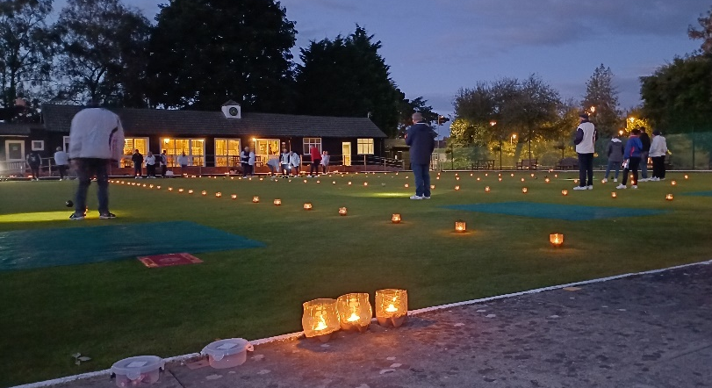
Thankfully the rain stayed away long enough for us to enjoy a Candlelit Bowls evening just before the end of the season. The game was followed by a fish and chip supper, and £140 was raised for Derbyshire, Leicestershire and Rutland Air Ambulance. This included a donation of £60 from Liz and Jim Marshall (thanks to you both). Thanks also to Marlene and Roger Bartlett for organising the night.

AGM, Officer Nominations and Proposals
This year’s Annual General Meeting takes place at the club on Saturday 7th December at 10.00am

Any proposal you wish to put forward for the AGM must be with Honorary Secretary Di Hurst by Saturday 26th October. Information on how to do this was emailed out on 14th September.

As the season has now finished, please send Officer nominations to Honorary Secretary Di Hurst by email. Please ensure you have a proposer and seconder and that the person nominated for the role is happy to do it! Many Role Descriptions were emailed in early September but please speak to the current office holder if you would like any information as to what each role involves.

All proposals, and nominations for club officers, should include a proposer and seconder.

Leicester Half Marathon
One of our members is running the Leicester Half Marathon on Sunday 13th October (no, it isn’t me!). Jennie Golding will be taking part (on her 44th birthday) and is raising money for LOROS. The race starts at 9.15am from Victoria Park and the route includes part of Watermead Country Park, and Whiles Lane, Front Street, Wanlip Lane and down Birstall Road towards Red Hill Circle. Jennie hopes to be running through the Birstall section of the race sometime between approx. 10.30am – 11.10am, she is wearing a white and yellow LOROS vest and her race number is 2933. Support along the route would be appreciated and you can sponsor her by clicking on the link https://www.justgiving.com/page/run-loughborough with all donations gratefully received.

