Birstall Bowling Club Newsletter
June 2024

Bowls England Bowls’ Big Weekend
We had a sunny and warm (for a change) Saturday morning as we hosted a session as part of Bowls England’s Bowls’ Big Weekend last month. Plenty of visitors came to have a go and we were also joined by Commonwealth Games gold medallist Jamie-Lea Marshall.

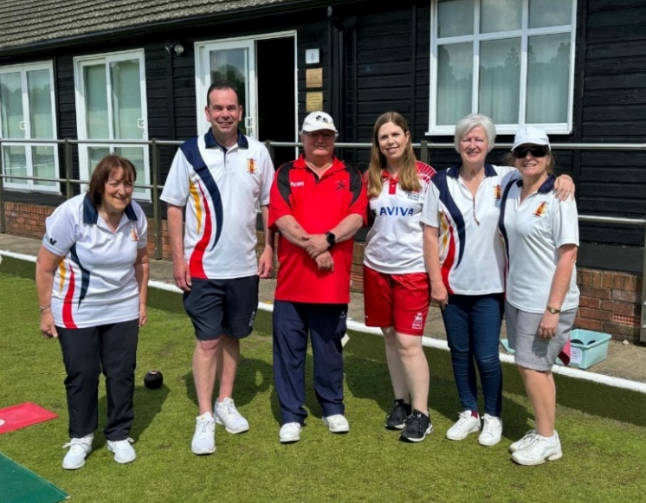
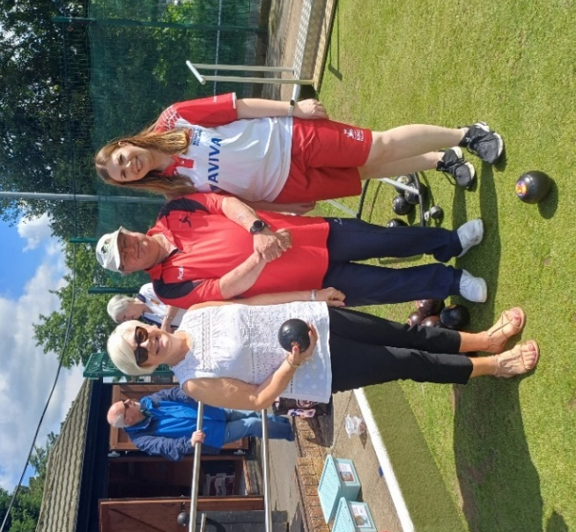
Thanks to everyone who helped out during the morning welcoming visitors and offering advice and assistance.

County Competitions
Pa Walker’s four (including three from Marlene Bartlett, Julie Beamish, Lesley Moore and Noi Pimprasan) play Sharon Cobb’s New Lount four in the county quarter final at Barwell on the morning of Sunday 16th June. If they win that game, they play the semi-final later the same day for a place in the county final and qualification for the national finals at Leamington.

Our ladies unbadged team play away at Countesthorpe in the quarter final which is to be played by Saturday 6th July.

Our men’s unbadged team play Oadby away in their first game, and we play Westcotes in the first round of the men’s county cup with two rinks at home and two away.

Just a note that if you are the named entrant in any county competition, please ensure that you have added the names of the rest of your team on the portal. Without the other names, you will be unable to submit a result when you win.

Bowls Leicestershire’s competition website www.bowlsleicestershire-admin.com has all the details of our members progress in the various county competitions.

National Competitions
Our ladies Top Club team had a great win over New Lount in the first round and play away at Countesthorpe in the next round on Wednesday 5th June (6.00pm).

Having beaten Leicester in the first round of the men’s Top Club our next game is away to Blaby on Friday 7th June. The men’s Two Fours team were beaten away at Quorn in the first round.

In the Tony Allcock Over 60s Mixed Two Fours competition, we beat Fosseway in the first round and now face Kingscroft away in a tie to be played by Sunday 16th June.

Members are also involved in individual competitions and you can keep up to date with their progress by visiting the Competitions Portal section at www.bowlsengland.com

Club Competitions
Most of the men’s club competitions have seen their play by dates extended by a couple of weeks. Please ensure that all comps are played in good time to keep them running smoothly.

League News
Both of our teams top their divisions after four matches in the men’s Loughborough Triples League. The next fixtures on Monday 10th June see Sands at home to Fosseway in Division One, and Lighthouse away to Soar Valley in Division Two, with both matches starting at 2.00pm.

We have played five games in the men’s Leicester League and sit fifth in the Division One table. The next game is at Blaby on Wednesday 26th June (6.15pm). We play St Margarets in the cup on Wednesday 5th June (6.15pm) with two rinks at home and two away.

At the halfway stage in the ladies Tuesday Morning Triples League, we are bottom of Division Two with the next fixture away to Fosseway on Tuesday 18th June (10.00am).

The first match in the ladies Aussie Pairs competition takes place at home against Shepshed on Monday 10th June starting at 6.00pm. The format for this new competition is three pairs with two points for each winning pair and two points for the aggregate score.

The first round of matches in the Ladies Friday Triples League start on Friday 21st June.

Coaching
One of our club coaches, Gary Kilbourne, is kindly offering to do coaching sessions on Friday afternoons between 4.00pm – 6.00pm. If you are interested, please speak to Gary.

Chummy Sessions
Due to matches in the ladies Aussie Pairs competition being played on Monday evenings, the Monday chummy session will now be in the morning starting at 10.30am. The other two sessions on Tuesday evenings and Friday evenings (both 5.45pm for 6.00pm) remain unchanged.

